**FAKE DONATION SITE SCAM (PayPal capture)**

**BY t.me/gr4y_a1pha (@Gr4y_A1pha)**

We will need a fake created donation webpage you can use wordpress.com and build it from scratch then you can export your page and change some HTML settings to make it look like real and not built from word press.

I am using a military based donation but u can use donation templates that can be used globally. These donation scams are good for your Smtp warm ups like sendgrid!

1. Upload the zip file of ur website to your host. I am using a Free dns provider u can use any.

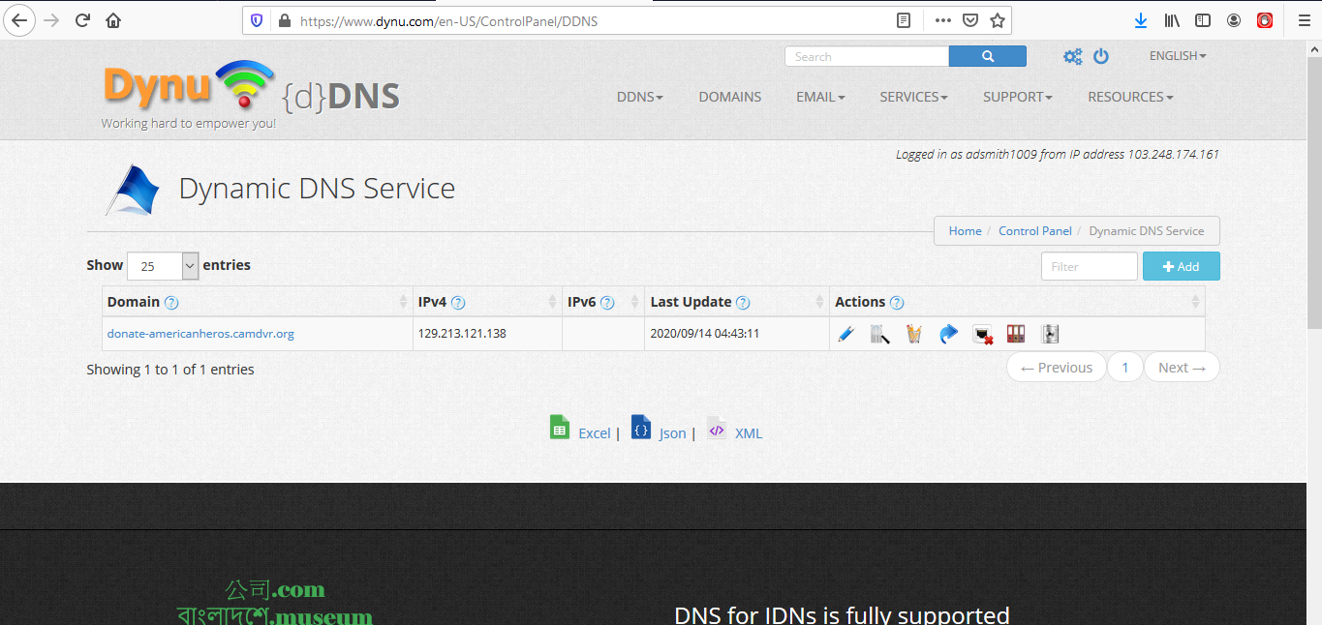

Now Upload the zip file of ur site to the host from cpanel

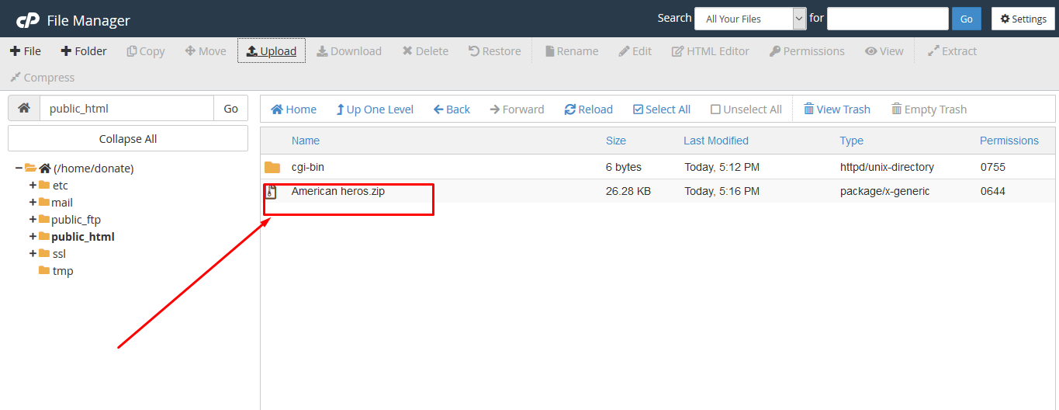

After done u can extract the zip file and you need to make a few changes into it like changing the web locations and all. Like my website has 3 pages one is the contact us page one Is the donate page. We will need to put links in the buttons so that the site looks legit. If a victim clicks on contact us then he can visit the page. Like shown in below figures.

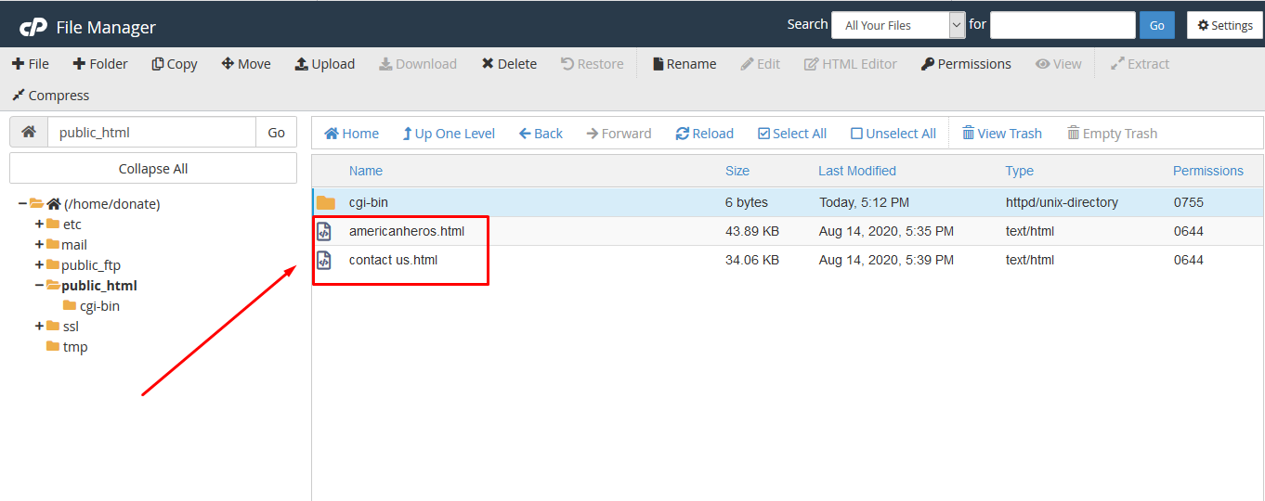



In my website you can easily change it by looking up theamericanheros.theworkpc.com/contactus.html and chase this url to whichever domain You host it on.

After all this is done you need to host a PayPal scam page and Put its url in the “DONATE US” Button. This way your page wont be detected easily and people wont hesitate to To provide more info.

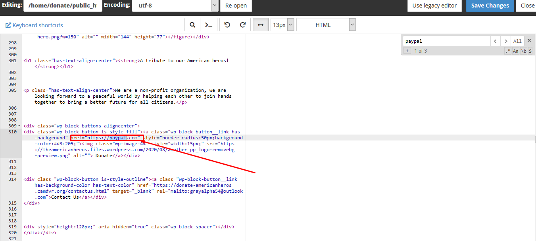

If you don’t want scam page you can also add real donations if you have a business paypal.

To replace the destination of redirect on Donate us page on my scam site you can easily lookup paypal.com and replace with your scam link!

You can send Bulk emails and all emails will mark it as promotional and it will never go spam by any smtp!!

Thanks You!!

If you have any doubts you can contact me always!!!

Tutorial by: @Gr4y_A1pha

Channel: t.me/gr4ya1pha | t.me/grayalphasletters

If you like the tutorial please support use by joining and promoting our channels. Thank You!!